CURRICULUM VITAE

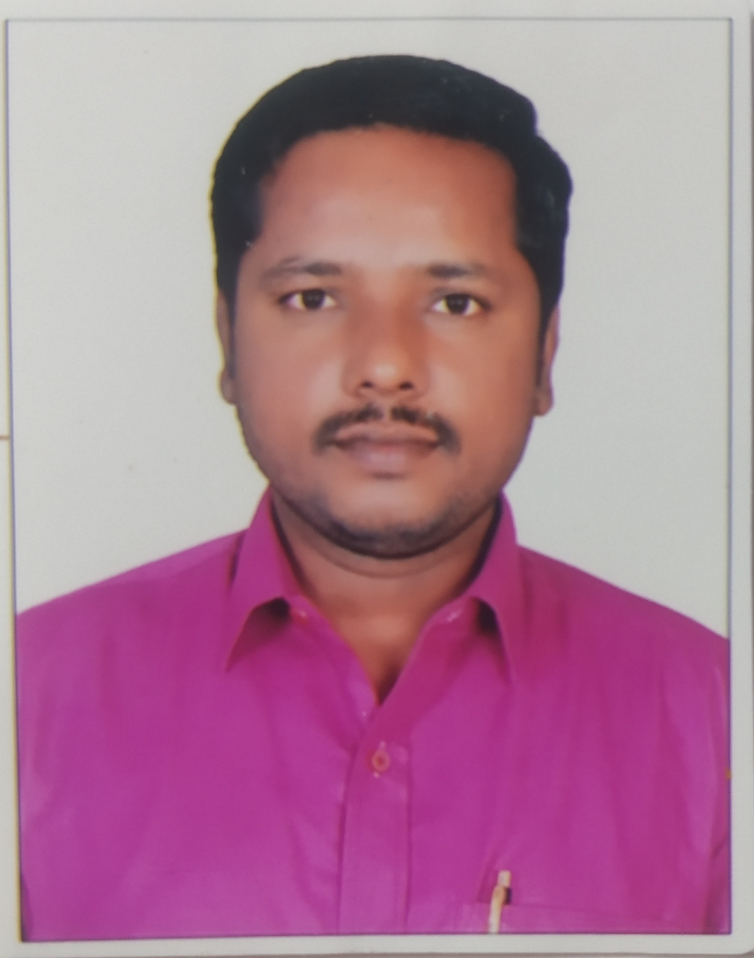

NAME : Dr. BHEEMANAIK.S

DESIGNATION : Assistant Professor

Department of Alankara Shastra

DATE OF BIRTH : 24-02-1987

ADDRESS FOR COMMUNICATION: Assistant Professor

Karnataka Samskrit University

Pampamahakavi Road, Chamarajpete Bangalore -560018

Phone: 7795634009
EMAIL: beema87naik@gmail.com

RESIDENTIAL ADDRESS: Ramjihatty (V), Buddnahatty (P),

Challakere (T), Chitradurga (D)

Pin Code: 577543

ACADEMIC QUALIFICATIONS : M.A, B.Ed. (Sanskrit), Ph.D.
ADDITIONAL QUALIFICATIONS : Qualified NET Examination

In the year 2014 Conducted by UGC
YEAR OF PH.D. THESIS AWARDED : 2019
AREAS OF SPECIALIZATION : Alankara Shastra, Language and Literature
Educational Qualification:
SL No | Exam Passed | University Board | Year of Passing | Class | Percentage
1 | Ph.D | Kuvempu University | 2019 | ---- | -----
2 | MA in Sanskrit | Kuvempu University | 2012 | 1st Class | 68%
3 | BA | Kuvempu University | 2008 | 1st class | 64.71%
4 | B.ed | Kuvempu University | 2009 | Distinction | 76%

ADDITIONAL QUALIFICATION:
- Qualified “National Eligibility Test”, Conducted, U.G.C for Lectureship (UGC Ref. No. 17048 – NET June 2014
- Ph.D in the Title “ Shivathathvarathnakaradallina Alankara Shastra Vimarshe”, in the Guidance Dr. G.V.Kallapura, it has been awarded by the Kuvempu University on 2019

EXPERIENCE:
- Assistant Professor Karnataka Samskrit University 03-02-2018 to still date

POSITIONS IN THE PROFESSIONAL ASSOCIATIONS:

Name of the Positions University/ Institutions Year
WARDEN- Karnataka Samskrit University, Bangalore 05-12-2020 to still date
N.S.S Program Officer Karnataka Samskrit University, Bangalore 21-01-2022 to still date
Department of alankara HOD Karnataka Samskrit University, Bangalore 12-04-2022 to still date
LANGUAGES:
- To Speak: Sanskrit, English, Lambani, and Kannada.
- To Read: Sanskrit, English, Kannada
- To write: Sanskrit, English, Kannada

ORIENTATION PROGRAMME AND REFRESHER COURSES ATTENDED:

- UGC – Orientation Programme: 124th Orientation Programme Conducted by UGC Human Resource Development Centre, University of Mysore, Mysore from 16-01-2020 to 05-02-2020(21days).

- UGC – Refresher Programme: 11th Refresher Programme Conducted by UGC Human Resource Development Centre, University of Mysore, Mysore from 17-12-2021 to 30-12-2021(14days).
ACTIVITIES IN THE UNIVERSITY:
- Worked as a co-ordinator for UGC NET Cell KSU, Bangalore
- Co-coordinator in Adhunika kavikavya smriti Series -2019, In Karnataka Samskrit University Bangalore
- One day Seminar Organized and Coordinator in Alankara Department, Karnataka Samskrit University, Bangalore held on 17-Aug-2020
- Coordinator One day Seminar Organized, in Alankara Department Karnataka Samskrit University, Bangalore -Rasagagadharasya Visayanirupanasaili as on 29-08-2022
- Conducted State and National Level (NET and SET), Training in KSU Bangalore-2021-22
- Assigned additional work to staff at the time of convocation in KSU Bangalore-2021
- Attended special 3 days workshop organized by KSU Bangalore-2021
- Dept of Alankara Conducted BOS Meeting as per NEP Regulation 2021
- Attended Special invited 2 days workshop of Joint Programmer organized by KSU Bangalore and Hampi 2021
- Worked as a coordinator for Department NAAC Coordinator 2022

BOARD OF STUDIES MEMBER (BOS):
- Member, Board of Studies in Department of Alankar Shastra, KSU as on 01-10-2021
- Member, Board of Studies in Department of Alankar Shastra, KSU as on 17-11-2021

OTHER ADMINISTRATIVE WORK:
- Working as a Boys Hostel Warden in Karnataka Sanskrit University, Bangalore still date.
- Assigned additional work to NSS Coordinator in Karnataka Sanskrit University, Bangalore 2022 to till date
- Working as a Department HOD in Alankara Shastra Date:12.04.2022 to still date..
WORKED AS A DIFFERENT COMMITTEE:
- Three Man Committee Member in Karnataka Sanskrit University, Bangalore as on 07-03-2020
- Three Man Committee Member in Karnataka Sanskrit University, Bangalore as on 19-11-2020
- Three Man Committee Member in Karnataka Sanskrit University, Bangalore as on 27-10-2021
- Three Man Committee Member in Karnataka Sanskrit University, Bangalore as on 16-09-2022
- Student welfare committee member in 2021.
- Committee Member of Ph.D Students Entrance Exam Question Paper Preparation 2021
- LIC Committee Member in Karnataka Sanskrit University, Bangalore

EXPERT COMMITTEE MEMBER:
- Expert Committee Member For Introducing Indian Knowledge System (I.K.S) in Karnataka Sanskrit University, Bangalore -18-08-2022

LIST OF RESEARCH PAPERS PUBLISHED INTERNATIONAL SEMINARS:
- Two days International Seminar on “Samskrutha Bhashege Paschimathyara Koduge”, organized by S.B Arts and K.C.P. Science College, Vijayapura held at 16-07-2018, ISBN: 9789383813346.

LIST OF RESEARCH PAPERS PUBLISHED IN NATIONAL SEMINARS:
- Attended One day National seminar on “Shikshana Keshthrakke Samskurthiya Prabhava”, organized by Kuvempu University, Shivamogga held on 25-03-2019 ISBN: 9789386855176.
- One day national seminar attended and Paper Presented on “ Fine Arts in Sanskrit and Prakrit Literature”, paper Title: Shivattatvarathnakaradallina Nruthya” organized by Karnataka University, Dharwad held on 20.12.2018 ISBN: 97893851540508
- Attended One day National seminar on “naishada kavyadalli parisara patra”, organized by University of Mysore Department of studies in sanskrit, Mysore held on 26-02-2020 ISBN: No 978-1-56646-725-4

LIST OF RESEARCH PAPERS PUBLISHED IN CONFERENCE:
- One day National Conference attended and Paper Presented on “Water Concept in Sanskrit Literature” Title:” Shivattavarathnakaradalli Jalavisaya Chinthane”, organized in Department of Studies in Sanskrit University of Mysore, Mysore, held on 25-03-2019 ISBN: 9788193091081

- One day national conference paper presented on” Ecology in Sanskrit Literature “, Title: Naisadakavyadalli Parisarada Pathra”, organized in Department of Studies in Sanskrit University of Mysore, Mysore, held on 26-02-2020 ISBN: 978156647254

- One day National Conference on “ Agriculture in Sanskrit Literature”, Title: Kutilyanana Arthashastradalli Krushi vicharagalu”, Organized by Department of Studies in Sanskrit University of Mysore, Mysore, held on 15th July 2016 ISBN: 9788191023015

- One day National Conference on “Abimani prakashana”, Title: Namma Lekhakaru”, Organized by International Banjara Roma Organisationheld on 12020 ISBN: No 978-81-926902-9-2
- One day national conference paper presented on” Contribution of sankrit Language in Enriching Indian Languages“, Title:samskruthika kshetrakkeShivattavarathnakarada koduge”, organized in Department of Sanskrit.Prakrit & Ypga Karnataka University Dharwad held on 2021 ISBN: 978-81-951939-4-3

- One day national conference paper presented on” Vachaspati Shastri Joshi Yogasanjeevini“, Title: Yoga mattu sanajika tatwagalu”, organized in Department of Sanskrit.Prakrit & Ypga Karnataka University Dharwad held on 2022 ISBN: 978-81-951939-7-4

LIST OF RESEARCH PAPERS PUBLISHED IN NATIONAL JOURNALS:
- Bheemanaik. S.(2019), An International Multidisciplinary Quarterly Research Journal(AJANTA), Title: Shivattattvaranthnakaradallina Alankara Vichara”, VOL.No.08 Issue No:01, ISSN No.22775730 Page No. 57-63
- Journal of Veda Samskrta Academy Recognised in the UGC-CARE List A National Peer-Reviewed Journal ,Title. Samskrtasahitye alankarasya stham”VoL.NO.XVIII, ISSN, NO 2250-1711, Page NO. 124-127
- Journal of Veda Samskrta Academy Recognised in the UGC-CARE List A National Peer-Reviewed Journal National Conference in kuvempu University. ,Title.Manasolasa mathu gidamulika rasavaividya ”VoL.NO.I, ISSN, NO 2250-1711, Page NO. 75-77

LIST OF NATIONAL AND INTERNATIONAL SEMINAR ATTENDED:
- Attended two days International Conference on “Bruhadaranyakopanisth” Organized by Karnataka Samskrit University and Shuklayajurveda Mahasabha Trust(R)”, at Brachmachaitanya Mandiram, Bangalore held on 26th and 27th October 2018.

- Paper presented on “ Samskrutha Sahitye Alankarashastrasya Sthanam” conference on “50th Session of All India Oriental Conference Organized by Kaviklaguru Kalidas Sanskrit University, Ramtek, Nagpur held on 10-12 Jan 2020.

- Attended Two days national seminar on “Shri Harshavardhanana Naganada Natakadallina Tatvika Chinthane”, held on Karnataka Samskrit University, Bangalore on 27th-28, 2018.

- One day National seminar attended “ Gautama Buddha and Acharya Shankara: Philosophical Dialogue” Jointly Organized by Pali Institute, Kalaburagi and Karnataka Samskrit University, Bangalore in association it Bharatiya Vidya Bhavan, Bangalore held at 20th November 2019

- Two days national seminar Paper Presented and attended on “ Banabhattakritisu loka-sastra-darsanam”, Title: Banabattana Kadambariiyalli Alankara Vicharagalu”, Organized by Karnataka Sanskrit University and Poornaprajna Vidyapeetha, Bangalore, held on 11th and 12th January 2019.

- Attended One day National level Seminar on “ Hasthaprathi Shastra mathu sambrakshane Karyagara Kurithu ondedu adhyayana”, Organized by Karnataka Sanskrit University, Bangalore, held on 18th Oct 2018.

- Participated in National Level Webinar on” Is Ramayana Relevent Today”, Organized by the Department of Hindi, Sanskrit and IQAC, SBRR Mahajana First Grade College, Mysore, on 02.09.2020

- Participated on State Level Webinar on” COVID-19 Stress Management”, organized by State NSS Cell Department of Youth Empowerment and Sports and Karnataka Samskrit University, Bangalore on 08.09.2020
- Participated in National webinar on” Issues and Challenges of Integrated B.ed Course in the Vies of N.E.P-2020” held on 7th September 2020, Organized by S.V.R. National College of Education, Shivamogga

- Participated in one day national level webinar on” Transformation of Sanskrit Varsities National Education Policy.2020”, Organized by IQAC Cell, Karnataka Samskrit University, Bangalore on 24th August 2020

- One day International Webinar on” Relevance of Bhagavadgeeta”, Organized by Vishwachetana Samskrutha Patashale, Mysore, held on 08.08.2020

- One day international level webinar on “ Web-Resources and Their Usages”, Organized by the department of Library and Information Centre and Department of Commerce, S DV Sangh’s, Shri L.K.Khot College of Commerce Sankeshara Karnataka on 30th August 2020

ORIENTATION AND FACULTY DEVELOPMENT COURSES ATTENDED:

- Successfully Completed one Weeks International Level Online Faculty Development Program on” Excellence in Creative Teaching and Research”, Organized by IQAC Cell, Karnataka Sanskrit University, Bangalore 12th to 17th Oct 2020.

- Successfully Completed One Weeks National Level Online Faculty Development Program on” Impact of Covid-19 on woman Family, Health, Education and Employment”, Organized by women’s Study Centre, Kuvempu University, Shivamogga held on 17th to 21th Aug 2020.
- Participated in National Level Webinar on” Is Ramayana Relevent Today”, Organized by the Department of Hindi, Sanskrit and IQAC, SBRR Mahajana First Grade College, Mysore, on 02.09.2020

- Participated on State Level Webinar on” COVID-19 Stress Management”, organized by State NSS Cell Department of Youth Empowerment and Sports and Karnataka Samskrit University, Bangalore on 08.09.2020

- Participated in National webinar on” Issues and Challenges of Integrated B.ed Course in the Vies of N.E.P-2020” held on 7th September 2020, Organized by S.V.R. National College of Education, Shivamogga

- One day international level webinar on “ Web-Resources and Their Usages”, Organized by the department of Library and Information Centre and Department of Commerce, S DV Sangh’s, Shri L.K.Khot College of Commerce Sankeshara Karnataka on 30th August 2020

- Participated in a Three dey Worshop on Shadutvam Asadutvam vechanam’ 29.31.march 2021
- Participated in 5 dats program on impact of covid in 5day 19 on Women Famil Health Education and Employment held on August 17th 21th organized by womens Study Centre Kuvempu university shankaraghatta
- Participated in National Level One day National webinar Transformation of Sanskrit varsities national Education Policy 2020 Karnataka Samskrit University, Bangalore on24.08.2020
- Participated in National Level One day National webinar Issues and challenges of Integrated Bed course 7th sep 2020 Kuvempu university
- Participated on State Level Webinar on” COVID-19 Stress Management Karnataka Samskrit University, Bangalore 08.09.2020
- Participated in 3 days all india oriental conference AIOC Centenry kavikulaguru Kalidas Samskrit University Ramtek Nagpur on 10.12.jan 2020
- Participated in National Level One day Seminar on Relevence of Ayurveda and Yoga in Higher Education’ conducted on 7th April 2021by NAAC in collaboration with Karnataka Samskrit University, Bangalore

- Attend workshop on Sanskrit words having special grammatical reference in KSU as on 2021.

- Attend Seminar NAAC with KSU Bangalore as on 2021

- Sanskrit Department organized IQAC national webinar role of Indian languages in national education policy 2021

- International webinar series Sanskrit matthu rajakiya 2021-KSU

- International webinar series samskrutha mattu kannada sahithya rasagala mahahva 2021-KSU

- UGC Sponsored Webinar online webinar Leadership 2022

- UGC Sponsored Webinar online webinar Ethics 2022

- UGC Sponsored Webinar online webinar Language 2022

- KSU organized Dept of Manuscriptology international Digital workshop on MODI SCRIPT 2022 - -KSU

